Session 1 – house design

EASY TASK:
I want you all to make a house like this.....
I will give you step by step instructions

DESIGN TASK:
IDE – look at shapes of houses
FPT – sawing skills, gluing skills
DMA – using two pieces of square section wood, art straws and some card, can you make a house design of your choice?

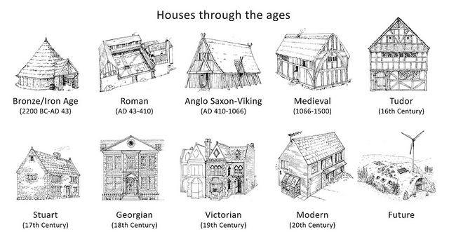

Session 1 – book design

EASY TASK:
I want you all to make a book like this.....
I will give you step by step instructions

DESIGN TASK:
IDE – look at examples of books and pop up cards
FPT – cutting skills, gluing skills, trying flaps and 3D effects
DMA – can you design pop-up book which explains how to saw safely?

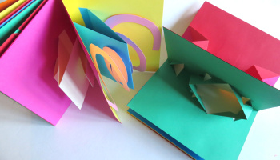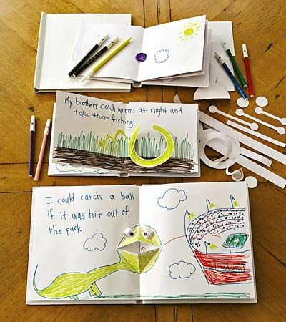
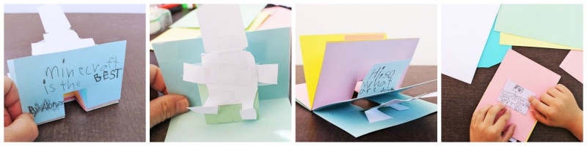

Session 2 – traditional tales (EYFS)

Resources: card, wood, lollypop sticks, artstraws, glue sticks, cardboard boxes, Lego
Tools: scissors, saws,

Billy Goats Gruff
IDE – story telling, experiment with bridges
FPT – cutting, gluing
DMA – build a bridge that will let the three goats travel safely over the troll

Three Little Pigs
IDE – story telling, block building
FPT – cutting, gluing, sawing
DMA – design a secure house for the three little pigs that will keep them safe from the wolf

Independent extension activity in groups - can you build these using Lego? K’Nex? Large scale model you can fit in yourself?

Gingerbread Man
IDE – story telling, lollypop puppets
FPT – cutting, gluing,
DMA – design and make a sliding story map of the gingerbread man.

Independent extension activity in groups – tell the story in a shadow puppet theatre using puppets made from a variety of junk modelling material.
Session 2 – Castles and Great Fire of London

Resources: card, wood, string, wheels, lollypop sticks, cotton reels, PVA glue, boxes
Tools: saws, bench hooks, scissors, drills, vice

Castles
IDE – castle designs, pulley experience
FPT – sawing, gluing
DMA – a nearby Lord needs a new entrance to his castle. Design and make a grand model entrance with a working drawbridge.

Great Fire of London
IDE – fire engine design, axels
FPT – sawing, gluing, making a frame
DMA – Sir Christopher Wren is really busy redesigning London and has asked you to help design a new fire truck that can pulled by horses and carry as much water as possible. Build a model that moves.

Victorians
IDE – look at different bridge designs, testing cylinders and triangles for strength
FPT – fixing materials
DMA – Isambard Kingdom Brunel wants to build a bridge over the Avonmouth gorge. Design a model using as little materials as possible.

Session 2 – Romans and Vikings

Resources: card, wood, marbles, corroflute, drainpipe, masking tape
Tools: saws, scissors, glue gun, hairdryer,

Romans
IDE – aqueduct designs, knowledge of Romans
FPT – gluing and use of tape to strengthen
DMA – a new villa has been built but it needs water. The best water is 50km away, can you build a 1:1000 aqueduct model from card and wood which transports 10 units of water (marbles)? There are other villas every 5km, can you reach them?

Vikings
IDE – boat designs, testing of different boat toys, knowledge of Vikings
FPT – sawing, use of hot glue gun, waterproofing
DMA – the Vikings are looking for a new boat design. Design and make a model boat which can travel down a canal the fastest using wind power. Use corroflute and wood to make your model.

Iron Age/Saxons
IDE – research hill forts, look at building designs and materials
FPT – card nets, wooden structures
DMA – design and make a hill fort, think carefully about where your defences and buildings will go to protect yourself from possible invaders.
Session 2 – Greeks and Egyptians

Resources: card, wood, elastic bands, circuit components, boxes, masking tape
Tools: saws, drills, scissors, wire strippers,

Greeks
IDE – catapult designs, pivot designs, elastic band designs
FPT – sawing, gluing, creating a solid frame
DMA – Dionysius of Syracuse has an idea for a new machine called a catapult. Build a working model using card and wood for him to show his carpenters.

Egyptians
IDE – circuits work
FPT – different switch designs
DMA – the Cairo museum wants to update their burglar alarm system to protect Tutankhamum's burial mask. Design and make a model that works to show the head of security.

WWII
IDE – look at Morrison and Anderson shelters, how they were made and materials used
FPT – fixing materials together, cutting unusual materials and use of glue gun
DMA – the Home Office have asked you to design a new bomb shelter that would be safe, comfortable. Design and make a model.

