Dear Hedgehogs,
I hope you had a good, restful half term. What have you been up to? I have been doing some gardening and exercising. I have even managed to finish another book!
This week in your home learning you are being asked to write a letter to someone. I could be someone you know (like a friend), a teacher or even someone famous. You can tell them about you, what you’ve been doing during lockdown and maybe even ask them a few questions. You never know if you show them (by sending it or tweeting them) they may even reply. Please email a copy of your letter to hedgehogs@greatwilbraham.cambs.sch.uk
Your Maths work will work like it did just before half term. You will no longer be able to access the worksheets from the White Rose link that we have sent. You can still find the week’s videos there. The worksheets can be found on the school website. Any problems with these please email me and I will do my best to help.
This week’s question I would love to hear your replies to is:
If you could turn into an animal for the day, what animal would you be and what would you do?
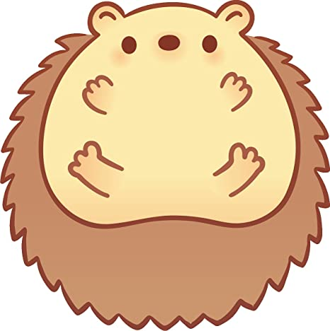
I would be an elephant. I would go splashing around in an oasis and roll in mud. Maybe even chase a few birds too.
Keep well and stay safe.
All the best,
Miss Luddy

