Dear Families,

I hope you have had a good week and are continuing to be safe and well. This week has been exceptionally busy, particularly after the reopening announcement that was only a week ago.

Questionnaire
Thank you for your comments and contributions to the online questionnaire. You may have seen a lot about schools in the news but I would like to confirm to you that we will take advice from DfE documentation, county and many other sources to do our upmost to open the school as safely as we can – for you, your families, the community, staff and of course children.

School environment
Some questionnaire responses asked for more detail regarding the class environment and I can confirm the school will look different to the school your children left. Whilst we will try to enjoy the outside space as much as possible, children will be in the same room for the whole day, 2m distancing will be enforced where possible, we will amend the behaviour policy, follow stringent hygiene expectations and have strict dropping off and picking up procedures – more detail to follow. Today we set up classrooms as they may look, this is version 1.0. We have removed soft furnishings, toys, book corners and shared equipment in accordance to the guidelines.

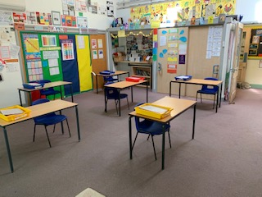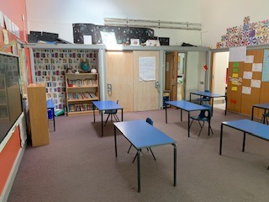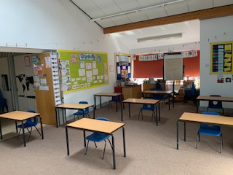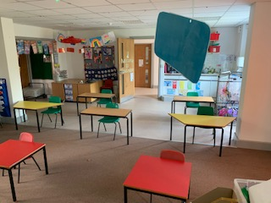

We are also considering the emotional wellbeing of children in this unfamiliar environment and teachers will be wary of the issues here. We will be spending the next two weeks considering the best approaches, taking advice from a number of sources. Physically and emotional safety are paramount.

Proposed school reopening
There has been a plethora of documentation to read and comprehend this past week and I will converse with the county, other schools, the staff and the Full Governing Body before releasing our intentions and plan for how we could facilitate a reopening, which year groups and the effects of doing so. Your patience and cooperation in this matter is much appreciated – this process needs to take time in order to get it right and be as safe as possible. I would dearly love to say that I knew the full details of the Prime Minister’s speech last week but my initial plans for reopening developed beforehand needed rethinking, certainly with the finalised guidance that was released Wednesday evening. County have confirmed that the scientific evidence from DfE to make the decision about the 1st June will not be known until the 28th May.

Everyone has been brilliant with their support and recognises that every school is different – different classroom sizes, resources, year group structure and available staff. The school decision will be informed and have the main priority of the safety of families, children and staff. I am also thankful to a parent volunteering her expertise and time last week to help risk assess the school with regards to virus control – thank you, it was much appreciated!

Personnel for September
I thought you should be informed that today I held interviews for a part time role at the school. Mrs Neish has requested a reduction in hours and will work three days from September. I am delighted to inform you that Mrs Jane Francis was interviewed today and accepted the role of part time senior teacher starting next academic year. Mrs Francis has already taught children at the school during the autumn term and will be a great addition to the school. We are delighted to have her join the Badger class team on Mondays and Tuesdays with Mrs Neish teaching Wednesday to Friday and Ms Noble teaching the class on Tuesday and Thursday afternoons.

Home learning and book swap
Thank you for your continued efforts, I know personally how challenging it is to juggle a full time job and deliver home learning at the same time. Some of you may be getting to the end of the books you have been provided. If you do not have any spare exercise books then please email admin@greatwilbraham.cambs.sch.uk and we will find a way of leaving one outside the school or at the next book swap for you. Book swap will not happen next Monday but I will try to facilitate another one on Friday, for older readers we have put out more books from the Badger class library that can be picked up.

Final thought of the week
We will be in touch before the end of the week about the future arrangements for after half term, but we will not know the final decision until the DfE release of the scientific evidence on the 28th May and our plans may have to change in light of this. We will stay alert to this. In the meantime, have a great week, enjoy the good weather and stay safe.

Richard Brown
Headteacher

Previous information sent to us from the county to pass onto you:

Children left at home on their own
There is national guidance for parents in the document - Closure of educational settings: information for parents and carers. It provides government advice on the law on leaving children unattended. There is no law about when a parent can leave your child on their own but it is an offence to leave them alone if it places them at risk. Parents should use their judgement on how mature their child is before they decide to leave them at home.

Parents can be prosecuted if they leave a child alone ‘in a manner likely to cause unnecessary suffering or injury to health’. The NSPCC recommends that children under 12 are rarely mature enough to be left alone for a long period of time, children under 16 should not be left alone overnight and babies, toddlers and very young children should never be left alone.

Children and young people’s mental health and wellbeing
The DfE has published on updated guidance on school closures. All NHS mental health trusts are setting up 24/7 helplines, and seeking to use digital and virtual channels, to continue delivering support during the pandemic. Social connections, alongside exercise, sleep, diet and routine are important protective factors for mental health. Resources to promote and support mental wellbeing are included in the list of online resources DfE has published to help children to learn at home. Public Health England has also published guidance on supporting children and young people’s mental health.

Digital support includes:
· Minded educational resources for adults about children and young people’s mental health, which is relevant for teachers, other professionals working with children, volunteers, parents and carers
· the Every Mind Matters platform, from Public Health England, about looking after your mental health
· Rise Above, targeted at young people, which also has schools-facing lesson plans

Scams
There have been reports of calls from somebody claiming to be from Public Health England, asking residents if they had received their letter from the government and then asking if they have support from family and friends, etc. and trying to obtain personal details – please remind people to be vigilant around sharing details.
https://theictservice.org.uk/service/online-safety-advice-for-parents-during-school-closures/?utm_source=The+ICT+Service&utm_campaign=2d10493553-EMAIL_CAMPAIGN_2020_04_02_02_57&utm_medium=email&utm_term=0_2d66a93e78-2d10493553-40627091

Online safety
Whilst the school is closed and children are using online learning more I thought it was pertinent to send this link which provides advice for families about online learning. Families may be concerned over cyber-bullying and this link provides good advice for monitoring what your children send and receive and the permissions they have.
https://theictservice.org.uk/service/online-safety-advice-for-parents-during-school-closures/?utm_source=The+ICT+Service&utm_campaign=2d10493553-EMAIL_CAMPAIGN_2020_04_02_02_57&utm_medium=email&utm_term=0_2d66a93e78-2d10493553-40627091

Early Years Key Worker provision
Schools, childminders and early years settings across Cambridgeshire and Peterborough remain open and are working hard to look after those children deemed vulnerable, and those of key workers. A dedicated team is now on hand to signpost parents to available options, including childcare provided by nurseries and childminders. If you are a critical worker and in need of childcare support, please contact the Family Information Service on:
- Cambridgeshire – 0345 045 1360
- Peterborough – 01733 864446 or visit the website

Primary Pupil Key Worker provision
We have not had any children in school since Wednesday 25th April but know that circumstances change. Please contact us to help facilitate provision whether in our school or more likely in another but please remember that the government has asked parents to keep their children at home, wherever possible, and asked schools to remain open only for those children who absolutely need to attend.

Supporting vulnerable people and families
In these very challenging times, all schools across Cambridgeshire and Peterborough are working closely with colleagues in Local Authorities to ensure families that are vulnerable or need additional support receive the help they need.

A network of COVID-19 Coordination and Response Hubs have been established, comprising a countywide hub and local hubs led by District/City Councils. The hubs are focussed on providing local support, coordinating community led initiatives, supporting residents, and responding to individual offers of help or requests for support including access to food banks.
The contact detail for our local hub can be found here:
South Cambridgeshire: www.scambs.gov.uk/coronavirus/
Monday to Friday 08:00-17:30 / Duty.communities@scambs.gov.uk / 03450 455 218

