TOGETHER, our vision as a Church of England school is to inspire each other to be thoughtful, polite, spiritual and curious individuals within our Christian community.

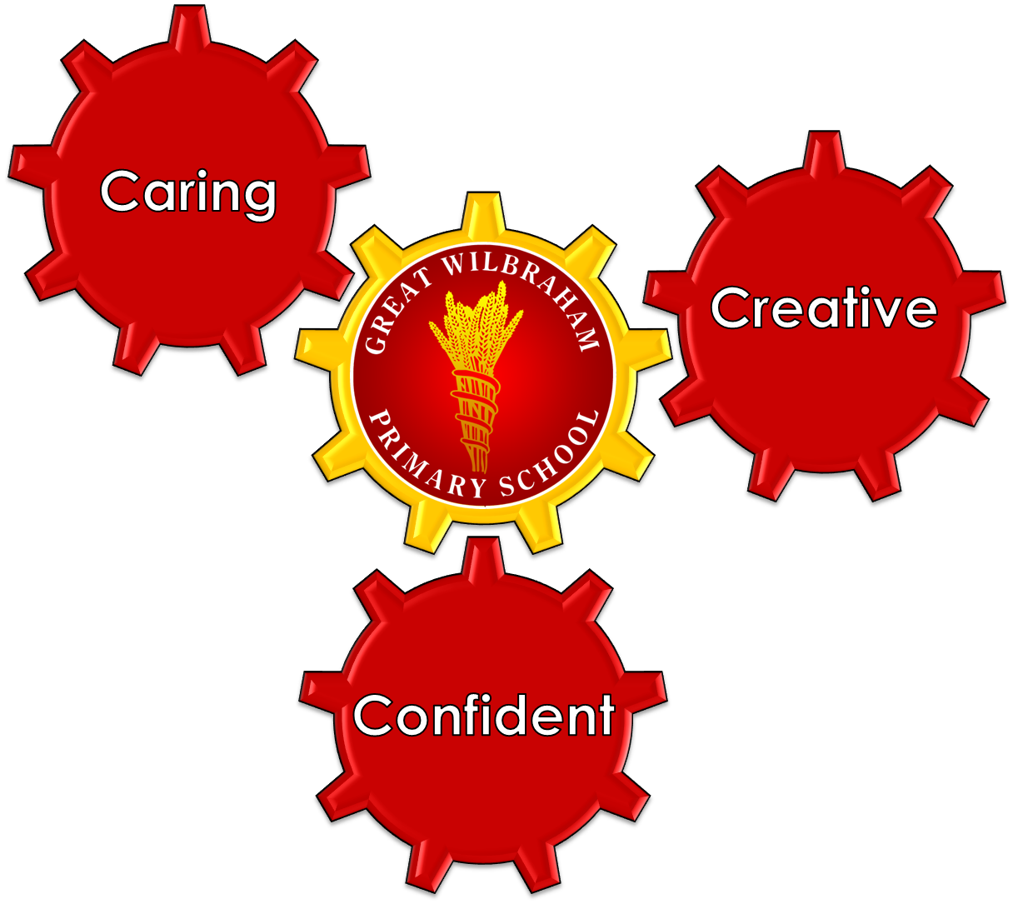
TOGETHER we make this happen.
TOGETHER we succeed.
TOGETHER we are:
CARING, CONFIDENT and CREATIVE learners
Ethos
At Great Wilbraham Church of England Primary School, children come first and our priority is to deliver high quality teaching and learning and provide rich and truly enjoyable learning experiences. Our school is based upon Christian principles where Christian concern is shown for all teaching and non-teaching staff, parents and children. By enabling our children to discover and develop their talents and spirituality, we will give them the strong foundations that will enable them to make a positive contribution to their community and leave us as lifelong learners.

Ely Diocesan Ethos Statement
Recognising its historic foundation, the school will preserve and develop its religious character in accordance with the principles of the Church of England and in partnership with the Church at parish and Diocesan level. The school aims to serve its community by providing an education of the highest quality within the context of Christian belief and practise. It encourages an understanding of the meaning and significance of faith and promotes Christian values through the experience it offers to all its pupils.

Values
Our vision that ‘Together we are caring, confident and creative learners’ intrinsically links to the Church of England Values for Life of which the Core Values for this school are Friendship, Respect, Courage and Creativity.

Together: | Friendship | Forgiveness | Trust | Service | Koinonia
Caring: | Respect | Peace | Thankfulness | Compassion | Agape
Confident: | Courage | Justice | Humility | Responsibility | Generosity
Creative: | Creativity | Truthfulness | Hope | Perseverance | Wisdom

Aims
At Great Wilbraham C of E Primary School and Nursery we will strive to:
- Promote Christian values, in accordance with the principles of the Church of England, whilst respecting the rights, beliefs and culture of each person
- Create a secure and stimulating environment where curiosity and the enjoyment of learning is paramount
- Provide a curriculum that is broad, balanced, relevant, progressive, appropriately differentiated; and provides opportunities for children to fulfil their true potential and explore and develop children’s values, beliefs and spiritual awareness
- Teach children how:
- to be effective problem solvers, thinkers and learners
- to keep themselves and others safe
- to lead a healthy life physically, emotionally, socially, morally, spiritually, culturally, and
- to acquire the key skills to enable them to adapt to a changing society
- Offer all children equal access to school life where individual differences are appreciated, celebrated, understood and accepted and value the individual interests and talents of each child
- Provide a supportive culture in which all staff are encouraged to extend, develop and share expertise
- Promoting the fundamental British values of democracy, the rule of law, individual liberty and mutual respect and tolerance of those with different faiths and beliefs
- Encourage children to become good citizens, by developing caring attitudes and respect towards themselves, other children, adults, their school and their community
- Foster close-knit links to the local and Church communities promoting co-operation and responsibility and become caring members of these communities in an atmosphere of mutual support of the school

SMSC
At Great Wilbraham CofE Primary School we promote the Spiritual, Moral, Social and Cultural development of children. Below are examples of how we achieve this.

Spiritual
Explore beliefs and experience; respect faiths, feelings and values; enjoy learning about oneself, others and the surrounding world; use imagination and creativity; reflect.

Moral
Recognise right and wrong; respect the law; understand consequences; investigate moral and ethical issues; offer reasoned views.

Social
Use a range of social skills; participate in the local community; appreciate diverse viewpoints; participate, volunteer and cooperate; resolve conflict; engage with the 'British values' of democracy, the rule of law, liberty, respect and tolerance.

Cultural
Appreciate cultural influences; appreciate the role of Britain's parliamentary system; participate in culture opportunities; understand, accept, respect and celebrate diversity.

British values
The Department for Education states that there is a need “to create and enforce a clear and rigorous expectation on all schools to promote the fundamental British values of democracy, the rule of law, individual liberty and mutual respect and tolerance of those with different faiths and beliefs.”
The government set out its definition of British values in the 2011 Prevent Strategy, which was updated in September 2015 to ensure there is a Prevent trained lead professional in every school who in turn disseminates training to staff working at the school.
As of November 2014, schools must promote British values. Advice from the DfE is to do so through SMSC, though Ofsted will assess it through the curriculum too. At Great Wilbraham C of E Primary School these values are reinforced regularly and in the following ways:

Democracy:
Children have many opportunities for their voices to be heard. An annual questionnaire gives them the opportunity to put forward their views about the school. Our School Parliament, made up of elected members from each year group, is split into 3 ministries -Caring, Confident and Creative. Each has a key role in running the school, discusses issues raised by pupils and has the power to effect change. Visits from local MPs and open debates and referendums help reinforce this message.

The Rule of Law:
Laws, whether they are those that have an impact on individual classes, the school or country, are consistently reinforced throughout the school day, through collective worship and when dealing with behavioural issues. Pupils are taught the value and reasons behind laws, that they govern and protect us, the responsibilities that this involves and the consequences when laws are broken. We are assisted in reinforcing this message by authorities such as the Police and Fire Service.

Individual Liberty:
Pupils are actively encouraged to make choices, knowing that they are in a safe and supportive environment. As a school we educate and provide boundaries for young pupils to make choices safety, through provision of a safe environment and empowering education. Pupils are encouraged to know, understand and exercise their rights and personal freedoms and advise how to exercise these safely, for example through our eSafety and PSHE lessons. Through choice of challenge, how children record or participation in extracurricular clubs and opportunities, pupils are given the freedom to make choices.

Mutual Respect:
Our school ethos and behaviour policy is influenced by Christian Values as stated in the Values for Life Diocese of Ely document. We promote respect for others at all times, in all situations and our mission statement, Collective Worship and PSHCE lessons reinforce that expectation. Pupils know and understand that respect is shown to everyone whatever differences we have.

Tolerance of those of Different Faiths and Beliefs.
As a Church of England Primary School we promote Christian Values but we ensure tolerance of those who have different faiths and beliefs. This is achieved through enhancing pupils understanding of their place in a culturally diverse society and learning about different religions through RE. Assemblies and discussions involving prejudices and prejudice based bullying have been followed and supported by learning in RE and PSHCE. Members of different faiths or religions are encouraged to share their knowledge to enhance learning within classes and the school, such as Parent Ambassadors leading school assemblies on their faith.

